* **Static analysis:** IF provides the dfa tool which implements classical static analysis techniques such as live variable analysis, dead-code elimination and variable elimination (backward slicing) with respect to user-defined criteria.
* **Model-checking: (Simulator?)** The core component of the IF toolbox is the IF simulator allowing to explore the underlying semantic model (i.e., state graph) of an IF specification. Several exploration modes are implemented: interactive (user-driven), random or exhaustive (breadth-first or depth-first). Partial order reductions can be applied in exhaustive depth-first search.

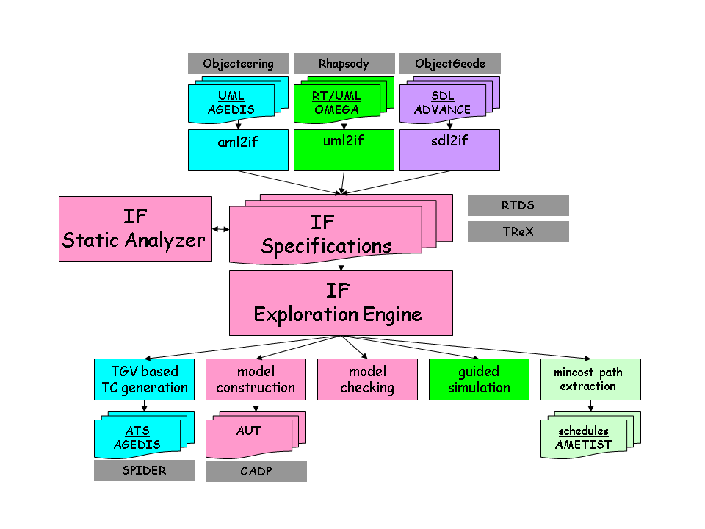

1 http://www-if.imag.fr/index.html